TASK 1

class BankAccount{  
 public String AccountNo;  
 public String AccountHolderName;  
 protected double Balance;  
 public void deposite(double amount){  
 Balance=Balance+amount;  
 // System.out.println("Here is the deposited Balance "+Balance);  
 }  
 public void withdraw(double amount){  
 Balance=Balance-amount;  
 // System.out.println("Here is the withdrawal Balance"+Balance);  
 }  
}  
class SavingAccount extends BankAccount{  
 double rate;  
 double interest;  
 public void interstRate(double rate){  
 this.rate=rate;  
 System.*out*.println("Annual interest is "+rate);  
 }  
 public void calculateInterst(){  
 interest=Balance\*rate;  
 Balance=Balance+interest;  
 System.*out*.println("Interest Earned is = "+interest);  
 }  
 public String display(){  
 return "Account no is "+AccountNo+"\nAccount Holder Name is "+AccountHolderName+"\nBalance is "+Balance+"\nInterest Rate is "+rate;  
 }  
}  
public class Main {  
 public static void main(String[] args) {  
 System.*out*.println("Lab 6 task 1");  
 SavingAccount a1 = new SavingAccount();  
 a1.AccountNo="22k-4079";  
 a1.AccountHolderName="Partham Kumar";  
 // a1.Balance = 500;  
 a1.deposite(1500);  
 a1.withdraw(500.0);  
 a1.interstRate(0.02);  
 a1.calculateInterst();  
 System.*out*.println(a1.display());  
 }  
}

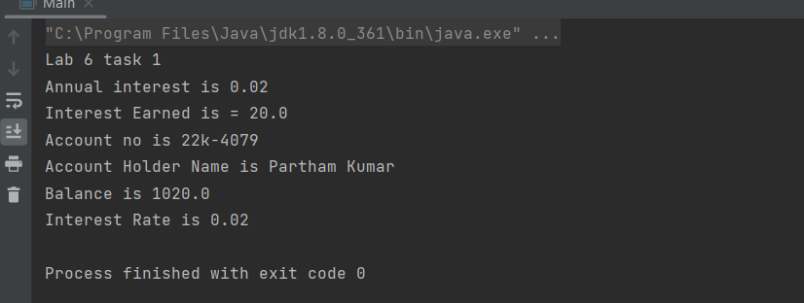

TASK 2

class Course{  
 protected String courseCode;  
 protected String courseName;  
 protected int courseCredits;  
 void setCourseCode(String courseCode){  
 this.courseCode=courseCode;  
 }  
 void setCourseName(String courseName){  
 this.courseName=courseName;  
 }  
 void setCourseCredits(int courseCredits){  
 this.courseCredits=courseCredits;  
 }  
}  
class undergraduate extends Course{  
 protected String departmentName;  
 protected int level;  
 void setDepartmentName(String departmentName){  
 this.departmentName=departmentName;  
 }  
 void setLevel(int level){  
 this.level=level;  
 }  
}  
class registration extends undergraduate{  
 private Course course;  
 private int numStudents;  
 private int maxStudents;  
 private boolean isClosed;  
 void setCourse(Course course){  
 this.course=course;  
 }  
 void setNumStudents(int numStudents){  
 this.numStudents=numStudents;  
 }  
 void setMaxStudents(int maxStudents){  
 this.maxStudents=maxStudents;  
 }  
 void setClosed(boolean isClosed){  
 this.isClosed=isClosed;  
 if (isClosed==true){  
 System.out.println("Your code Has been registered");  
 }  
 }  
 void registerStudent(){  
 if (numStudents==maxStudents){  
 System.out.println("Space is full");  
 }  
 else System.out.println("You can register");  
 }  
 String display(){  
 return "Level is "+level+"\nDepartment "+departmentName+"\nCourse "+courseName+"\nCourse Code "+courseCode+"\nCourse Credits "+courseCredits;  
 }  
  
}  
public class Main {  
 public static void main(String[] args) {  
 System.out.println("Lab 6 task 2");  
 registration s1 = new registration();  
 s1.setLevel(1);  
 s1.setDepartmentName("AI");  
 s1.setCourseName("Ethics");  
 s1.setCourseCode("SL 002");  
 s1.setCourseCredits(3);  
 s1.setMaxStudents(35);  
 System.out.println(s1.display());  
 s1.setClosed(true);  
  
 }  
}

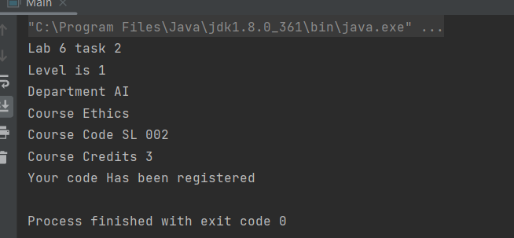

TASK 3

class rectangle{  
 double lengh,breadth;  
 double are,peri;  
  
 public rectangle(double lengh,double breadth) {  
 this.lengh = lengh;  
 this.breadth=breadth;  
 }  
 void area(){  
 are=lengh\*breadth;  
 System.out.println("Area of Rectangle is "+are);  
 }  
 void perimeter(){  
 peri = (lengh+breadth)\*2;  
 System.out.println("Perimeter of the Rectangle is "+peri);  
 }  
}  
class square extends rectangle{  
 double area,perimeter;  
 public square(double lengh, double breadth) {  
 super(lengh, breadth);  
 }  
 void Area(){  
 area=lengh\*lengh;  
 System.out.println("Area of the Square is "+area);  
 }  
 void Perimeter(){  
 peri=4\*lengh;  
 System.out.println("Perimeter of the square is "+peri);  
 }  
  
}  
public class Main {  
 public static void main(String[] args) {  
 System.out.println("lab 6 task 3");  
 square r1=new square(5.0,6.0);  
 r1.Area();  
 r1.Perimeter();  
 r1.area();  
 r1.perimeter();  
 }  
}

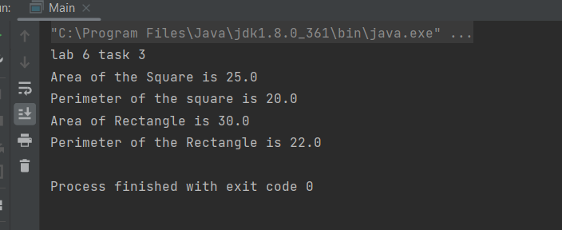

TASK 4

class Books{  
 protected String bookId,bookName,bookAuhor;  
 protected double ISBN,price;  
 void Books(String bookId,String bookName,String bookAuhor,double ISBN,double price){  
 this.bookId=bookId;  
 this.bookName=bookName;  
 this.bookAuhor=bookAuhor;  
 this.ISBN=ISBN;  
 this.price=price;  
 }  
 public String display(){  
 return "Book ID is "+bookId+"\nBook Name is "+bookName+"\nAuthor is "+bookAuhor+"\nISBN is "+ISBN+"\nPricr is "+price;  
 }  
}  
class catagory1 extends Books{  
 String catagory;  
  
}  
public class Main {  
 public static void main(String[] args){  
 System.out.println("Hello world!");  
 Books bi = new catagory1();  
 catagory1 c1 = (catagory1)bi;  
  
 c1.bookId = "22k-4079";  
 c1.bookName = "OOP In Java";  
 c1.bookAuhor = "xingzin";  
 c1.ISBN= 225225;  
 c1.price=50;  
 c1.catagory = "Coding Guide";  
 System.out.println(c1.display());  
 }  
}

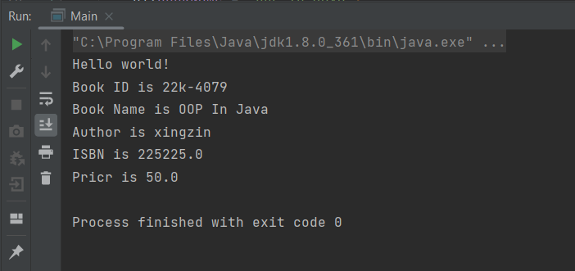

TASK 5

class vehicle{  
 int speed,noOfWheels;  
 String colour;  
 public vehicle() {  
 }  
 public vehicle(int speed,String colour,int noOfWheels) {  
 this.speed = speed;  
 this.colour=colour;  
 this.noOfWheels=noOfWheels;  
 }  
 void setSpeed(int speed){  
 this.speed=speed;  
 }  
 public void setColour(String colour) {  
 this.colour = colour;  
 }  
 public void setNoOfWheels(int noOfWheels) {  
 this.noOfWheels = noOfWheels;  
 }  
 public int getSpeed() {  
 return speed;  
 }  
 public String getColour() {  
 return colour;  
 }  
 public int getNoOfWheels() {  
 return noOfWheels;  
 }  
}  
class MotorVehicle extends vehicle{  
 String licenseplate;  
  
 public MotorVehicle() {  
 }  
  
 public void setLicenseplate(String licenseplate) {  
 this.licenseplate = licenseplate;  
 }  
  
 public String getLicenseplate() {  
 return licenseplate;  
 }  
}  
class car extends MotorVehicle{  
 int noOfDoors;  
  
 public int getNoOfDoors() {  
 return noOfDoors;  
 }  
  
 public void setNoOfDoors(int noOfDoors) {  
 this.noOfDoors = noOfDoors;  
 }  
 public car() {  
 }  
 String display(){  
 return "Speed is "+speed+"\nColour is "+colour+"\nNo of wheels = "+noOfWheels+"\nLicense Plate "+licenseplate+"\nNo of doors "+noOfDoors;  
 }  
}  
public class Main {  
 public static void main(String[] args) {  
 System.out.println("Lab 6 task 5");  
 vehicle v1 = new MotorVehicle() ;  
 MotorVehicle M1 = new car();  
 car pk = new car();  
 pk.setSpeed(220);  
 pk.setColour("Blue");  
 pk.setNoOfWheels(4);  
 pk.setLicenseplate("BBQ-592");  
 pk.setNoOfDoors(4);  
 System.out.println(pk.display());  
 }  
}

